**1. WAP to create ordered , unordered and nested list in html.**

OUTPUT

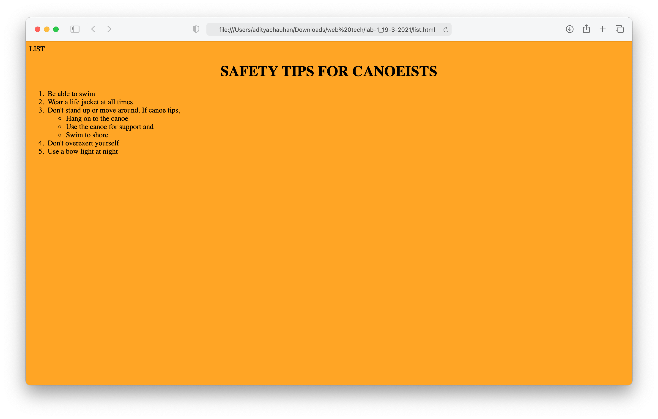

**2. WAP to create table with borders.**

**OUTPUT**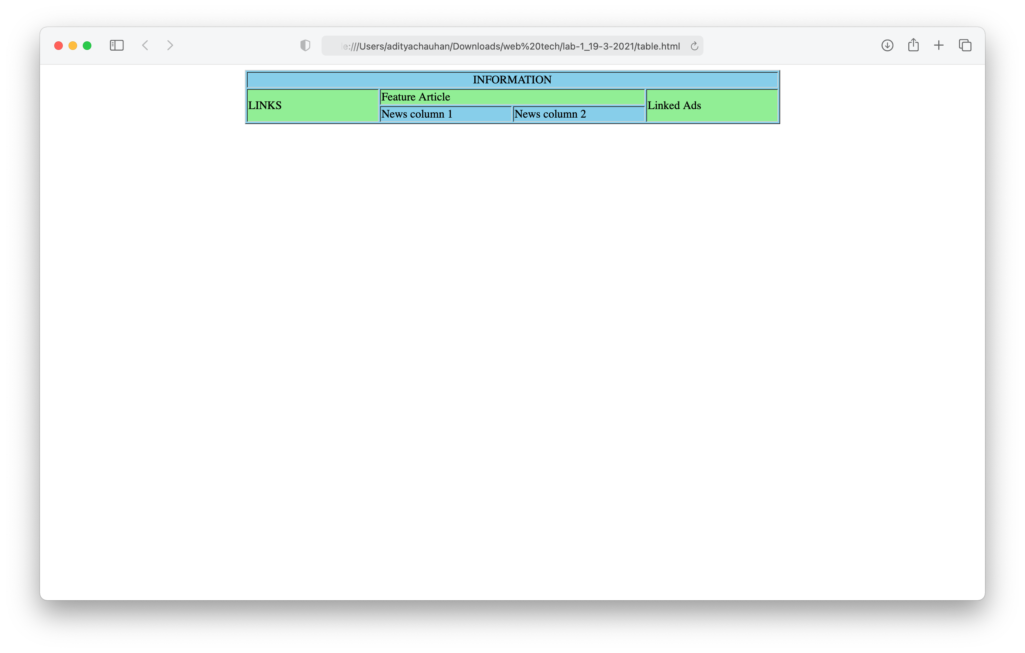

**3. WAP to create a survey form.**

**OUTPUT**

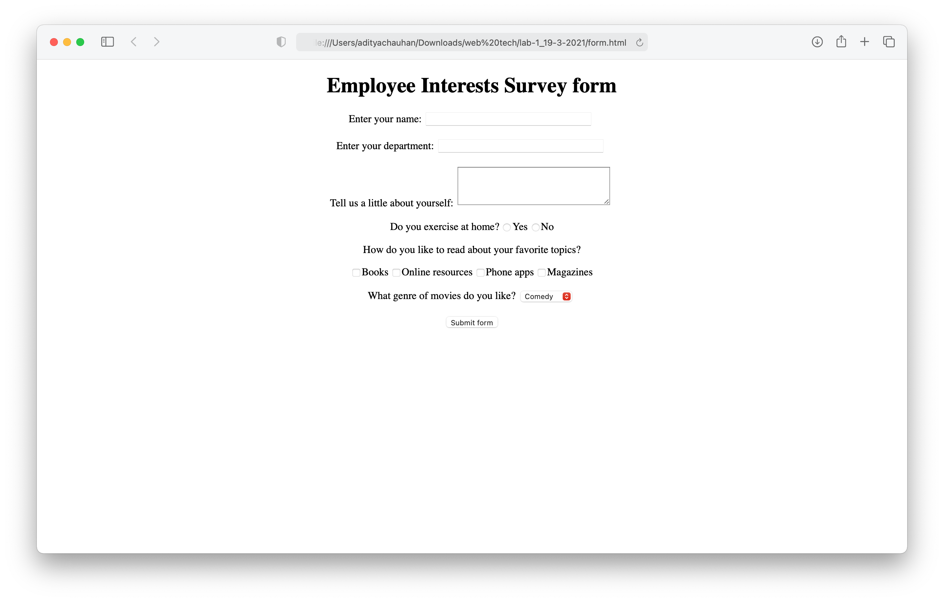

**4. Write a program to provide styles to html elements.**

**OUTPUT**

